1. When we look at the Elite API we have noticed that currently the authorization token is generated based on our existing customers. So if we have a new customer signing up then we don't have this token and sign up api call will always fail. We prefer to have the token generation based on the api users configured in your database.

You can use the customer sign-up with no authentication.

Dev Comments : Database Insertion without proper authentication may lead to security issues(Any one can insert data).

We need the token for each and every API call and that needs to generate based on the api users and not based on patients

The Authentication type changed to basic authentication. For Credentials, please find the updated document.

Dev Comments: Verified

1. Is Valid Customer
2. Even if we are not passing mobile and Qatarid, the response is it is a valid customer and returning all the patient details.

We have corrected.

Dev Comments: Verified

1. Customer Signup
2. If we try to save the same data twice or with data without qatarid the response shown as success. Need to set required option for all fields and return correct error message if the patient is already registered.

Currently the required fields are FirstName, Gender, MobileNo and QatarId. So when we try to insert only using these fields there are some issues in the data saved.

1. The FirstName has a postfix, space and single inverted comma ( ‘).

Issue Fixed

Dev Comments: Verified

1. Even though we have not provided DOB,it is saved as 01-01-1990 by default in db

We have added validation because inour HMS system, DOB is a mandatory field so, the field should have value.

Dev Comments: Verified

1. Please Return Saved PatientId also

Done

Dev Comments: Verified

.

1. After we send the request the response is success. Then we try to validate this patient using the QatarId and MobileNumber and the response is “Invalid Customer”. Please check whether this data is saving correctly

We have corrected.

Dev Comments: Verified

1. Please provide the table name

PatientM.

Dev Comments: Ok

1. Get All Active Doctors
2. DepartmentId, DepartmentName and doctor photo is not returned

You can get the details now. shared the doctor’s photo as binary.

Doctor_Id -D164 (Sample photo added)

Dev Comments: Verified

1. Get Available time slots of doctor
2. In the document provide the end point is GetAllDoctors(API/ConsultantDetails/GetAllDoctors)and passing doctorId. But it is returning all doctors list.

Just For Confirmation :- Is that slots will list today’s time slot only. If so,we need to pass appointment date also, so that you can return slots on that particular day

I have already added fromdate and todate for appointment filtering. Please find the document for the details.

Dev Comments: Verified

1. Book Consultation
2. DoctorName and booking status is not needed in request (Mistake from our end).

Removed the mentioned fields.

Dev Comments: Verified

1. Can’t test properly because can’t find doctorid on that schedule. Please provide a doctorId for this testing. The error message is in the result and issuccess is true(In this case IsSuccess need to be false and proper message should be returned in “message”)
2. Please make sure the request fields BookingForName, BookingForGender and BookingForRelation should be mandatory when IsBookForAnotherPerson is true. Currently it’s allowing to save without that data.

Validation Added

Dev Comments: Verified

1. Able to save data with past consultation date

Validation Added

Dev Comments: I have tried previous date and the validation is working fine. But when I tried with today’s date with past time validation not works and data saved to db

Check It Now

Dev Comments: Verified

1. Please return saved AppointmentId also

Done

Dev Comments: Verified

1. Please Provide Table Name for verification

ConsAppointments

Dev Comments: Ok

1. Able to take multiple appointment for same patient on same day

If the flag Is BookingForAnotherPerson is 1 then the validation does not work. because, in that case, we are saving patient id as 0. Please change the flag BookingForAnotherPerson to 0 then it will work.

Dev Comments: So if you are not saving patient Id if he is booking an appointment for his child, how can we see that appointment in our upcoming appointments that’s fetching using patientid. I have tried creating an appointment with BookingForAnotherPerson is 1 and that is not retrieving in upcoming appointments

Fixed. Please verify.

Dev Comments: Verified

1. Get All Upcoming Appointments

a). Not testedbecause of no appointments saved.

b). Return appointment status only if it is available in your HMS system.

Doctor photo is not returned(Empty value).

Please check now.

Dev Comments: Verified

c). Dev Comments: IsCancelled field is returned as string here. In Get Appointment Details it is returned as integer. Please make the datatype uniform for this field in all end points, preferably Boolean

Done

Dev Comments: Can’t verify because it is not returning any data

Dev Comments: Verified.It is returning Integer

1. Consultation booked and upcoming appointments doesn’t returning any data

Set IsBookingForAnotherPerson flag is 0 while save consultation then it will show.

Dev Commets: We need to get upcoming appointments of the bookings he made even it is for another person

Fixed. Please verify.

Dev Comments: Verified

1. Cancel Booking
2. Seems like wrong end point(API/AppointmentDetails/GetAllUpcomingAppointmentsByPatientId)
3. Can’t testedbecause of no appointments saved.

Dev Comments: Error in functionality

Corrected

Dev Comments: Verified

1. Get Appointment Details
2. Not testedbecause of no appointments saved.
3. Please return IsCancelled also and Return BookingStatus only if it is available in your HMS system
4. Please return IsSuccess false and proper message when wrong appointmentid is passed

Done

Dev Comments: Verified

1. Even though we have provided IsBookForAnotherPerson,BookingForName, BookingForRelation while saving appointment, it is not returned here

Done

Dev Comments:Verifed returning fields IsBookForAnotherPerson and BookingForRelation. BookingForName is not correctly saved into db and it is returning the patient name itself

Done

Dev Comments: Verified

1. Please return BookingForGender also

Done

Dev Comments: Verified

1. After booking is cancelled booking details can’t be fetched

Done

Dev Comments: Verified

1. Booking History
2. Seems like wrong end point (API/AppointmentDetails/GetAppointmentDetailsByAppId)

Please find the attached modified document for the information

Dev Comments: Verified end point is working correctly

1. Not testedbecause of no appointments saved.
2. Return AppointmentStatus only if it is available in your HMS system
3. Doctor Photo is not returned(Empty value)

Please Check Now

Dev Comments: Verified

1. Customer Details
2. Seems like wrong end point (API/AppointmentDetails/GetAppointmentDetailsByAppId)

Please find the attached modified document for the information

Dev Comments: Verified

1. I have tried another end point (api/PatientDetails/GetPatientDetailsByPatId) and error thrown as “Could not find stored procedure 'GetPatientDetailsByPhNo'”

Please find the attached modified document for the information

Dev Comments: Verified

1. Get All Reports

Seems like wrong end point (API/AppointmentDetails/GetAppointmentDetailsByAppId). Please verify

Return IsSuccess false and correct message when there isn’t any reports for the patient

Validation messageadded,IsSucces flag corrected

Dev Comments: Verified

1. Get Report Details

Seems like wrong end point(API/AppointmentDetails/GetAppointmentDetailsByAppId)

Dev Comments: Report file is not returned. Please set IsSuccess false when invalid ReportId is passed

Validation messageadded,IsSucces flag corrected

Dev Comments: Verified validation. Report File still not returned. I have tried passing the reportId that I have got in GetAllReports

Currently the report file saving facility not in our application. we will update after discussion.

Dev Comments: Pending

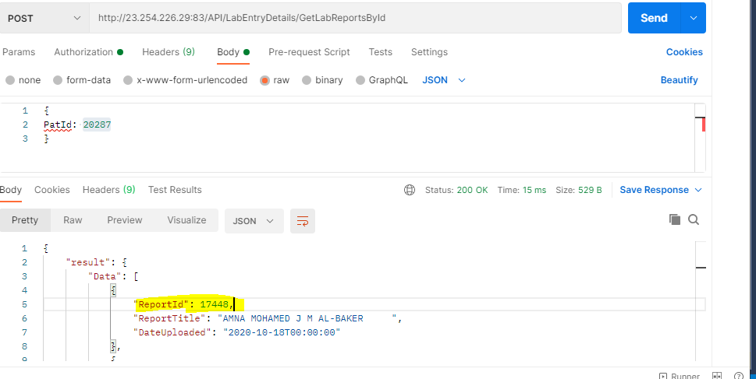

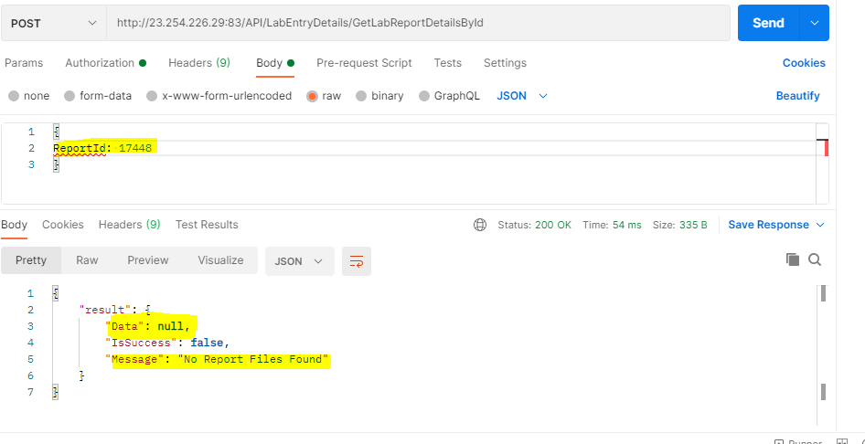

1. Two more Request from our side
2. Can you please create a new end point for updating the patient fields that’s used in creation(API/PatientValidation/SavePatientDetails)

We will do after confirmation.

1. Can you please remove the end points BookingHistory and Upcoming Appointments and return that in a single endpoint. Please add Cancelled list also in this. Data structure will be as below

We will do after confirmation.

 "result": {

        "Data": {

            "UpcomingAppointments":[

{

             },

{

}],

"CancelledAppointments":[

{

             },

{

}],

"BookingHistory":[

{

             },

{

}],

        },

        "IsSuccess": **true**,

        "Message": "Successfully"

    }

}